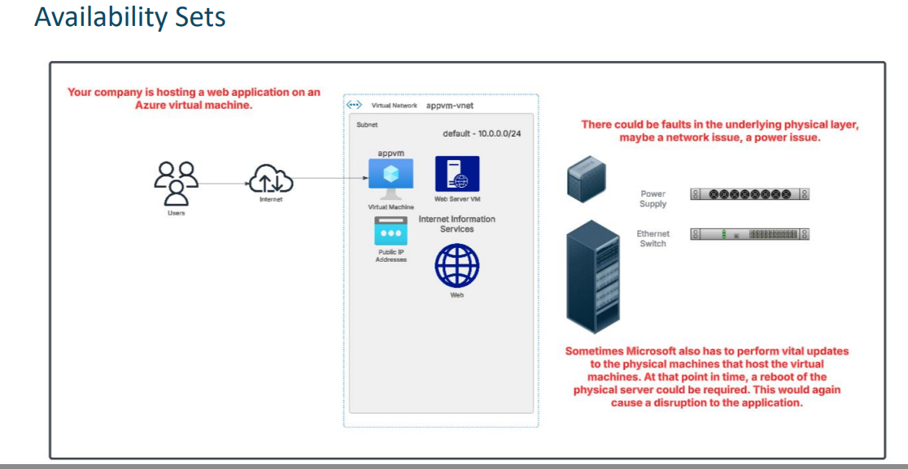

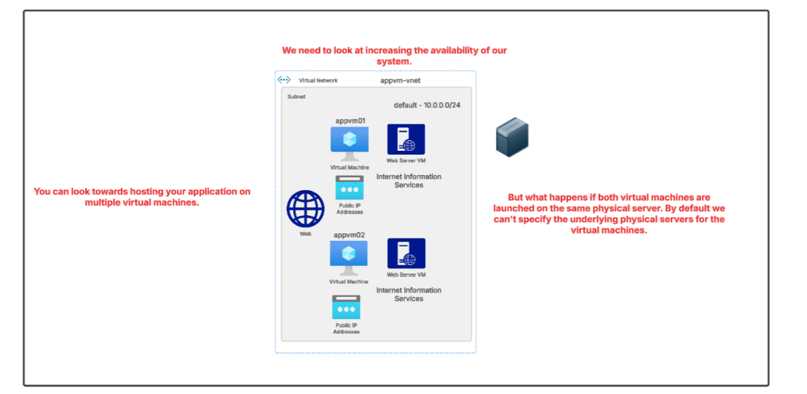

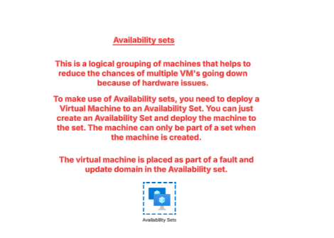

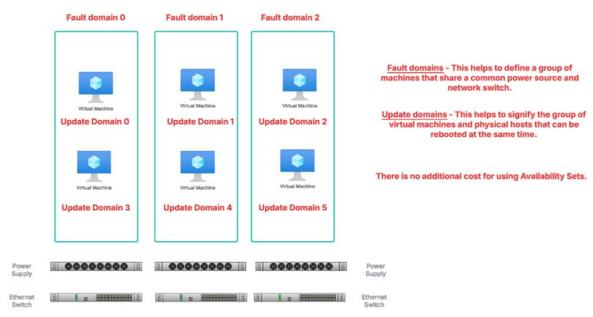
Even inside the same Fault Domain, Azure will never update VMs in two Update Domains at the same time.
It updates one Update Domain at a time → so only one VM gets updated.

💡 Extra Tip
Fault Domain = hardware failure
Update Domain = planned update/reboot by Azure
So update domains protect you from planned downtime, even if hardware domain is same.

2) Availability Sets - Review
When you host your virtual machines in Azure, you sometimes need to cater to the following
- An unplanned event wherein the underlying infrastructure fails unexpectedly. The failures could be attributed to network failures , local disk failures or even rack failures.

- Planned maintenance events , wherein Microsoft needs to make planned updates to the underlying physical environment. In such cases , a reboot might be required on your virtual machine.
You can increase the availability of your application by making use of availability sets. Each virtual machine that is assigned to the availability set is assigned a separate fault and update domain.
Fault domains are used to define the group of virtual machines that share a common source and network switch. You can have up to 3 fault domains.
Update domains are used to group virtual machines and physical hardware that can be rebooted at the same time. You can have up to 20 update domains.

• Availability Zone → VMs in different datacenters
• Availability Set → VMs in different racks of the same datacenter

3) lab of avalilability:-
GO TO THE VM AND CREATE THE VM ,
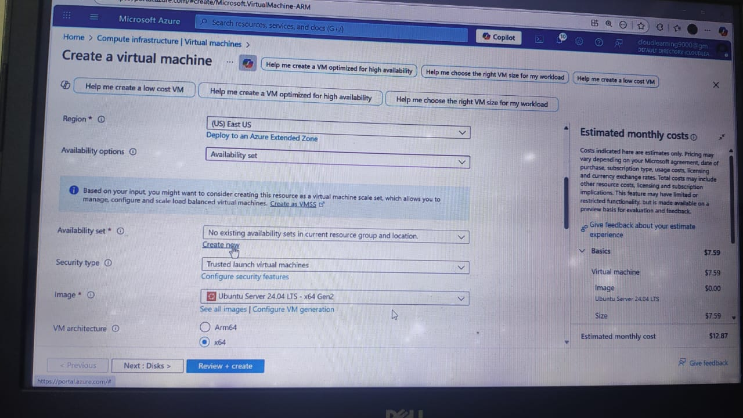
SLECT THE AVALIBILITY SET AND CREATE FAULT DOMAIN AND UPDATE DOMAIN.
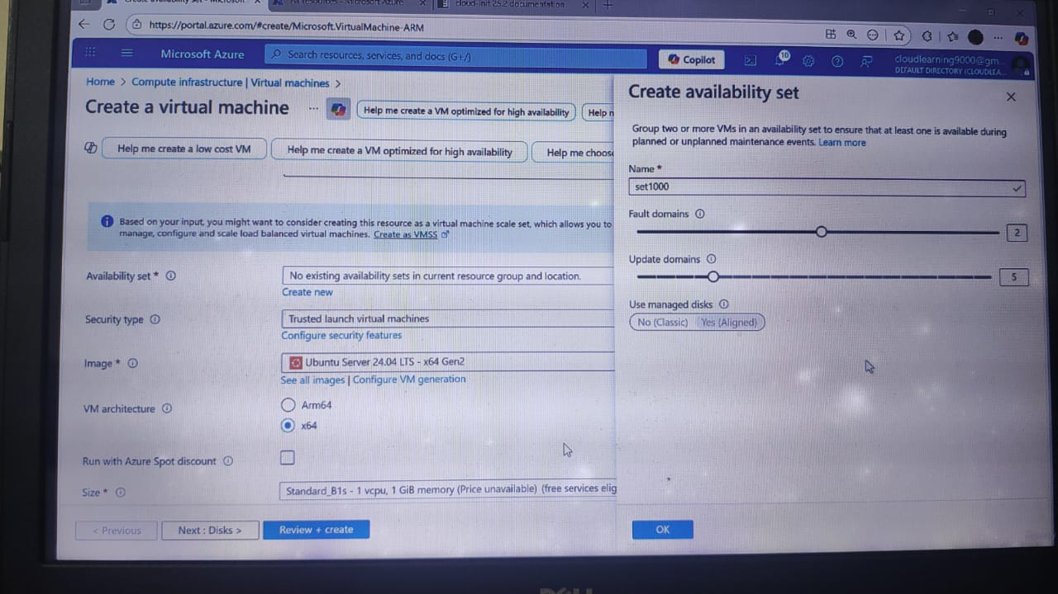
AFTER THAT GO TO THAT SET FRO RESOURCE GROUP U CAN SEE THAT VM HAVE NOW FAULT AND UPDATE NUMBER.
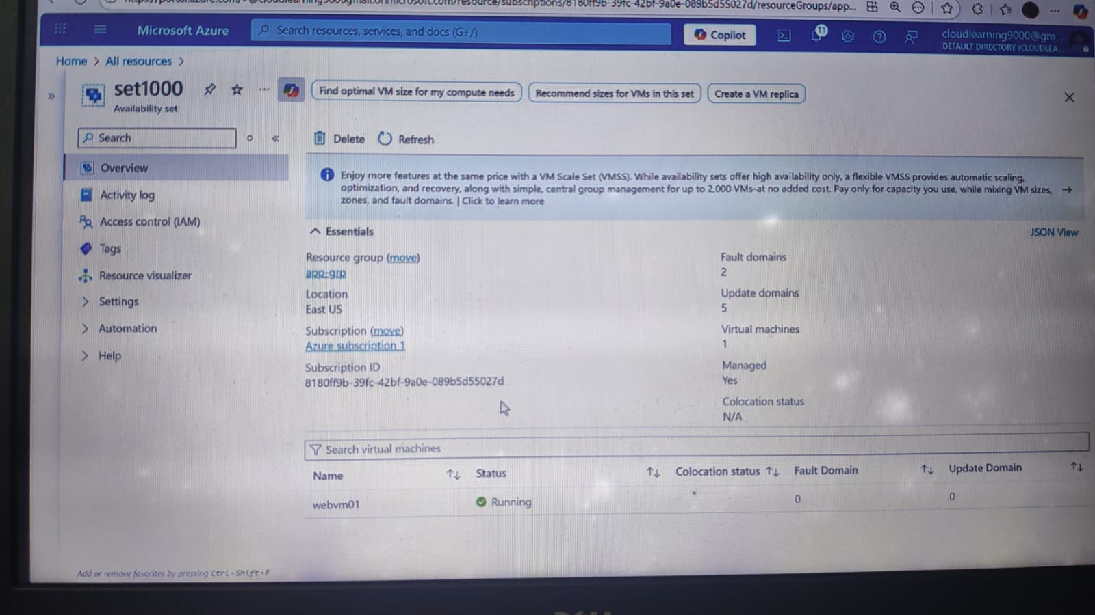
NOW CRETAE ANOTHER VM AND ASSIGN THIS AVALIABILITY SETS.
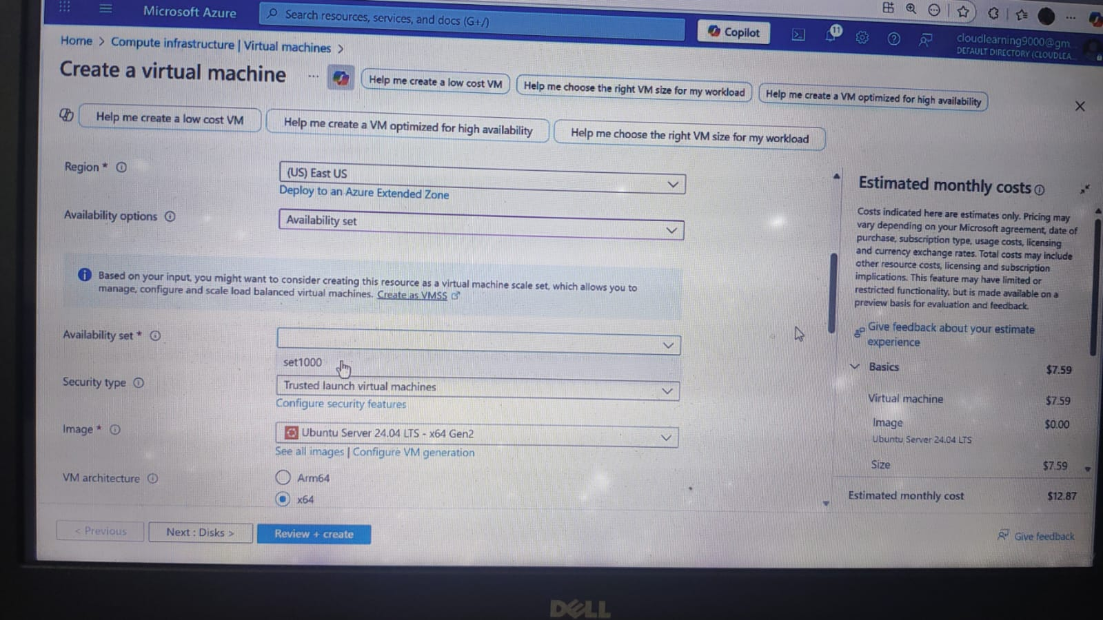
AFTER THAT AGAIN GO TO THE SET AND SEE.
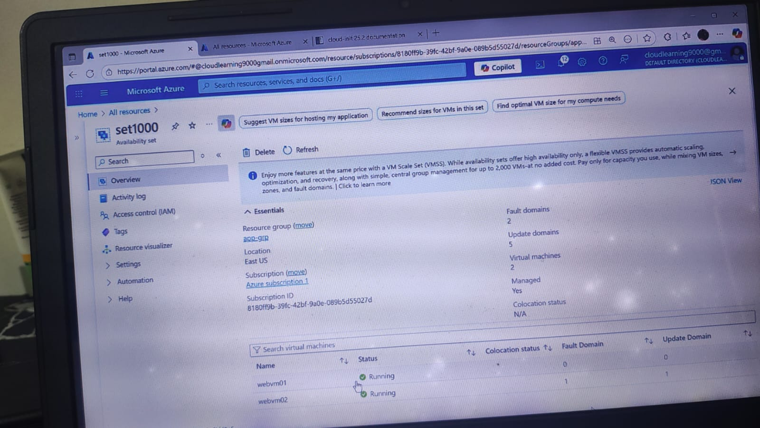

5)
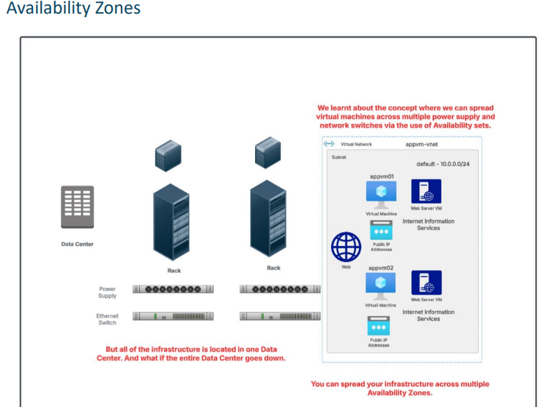
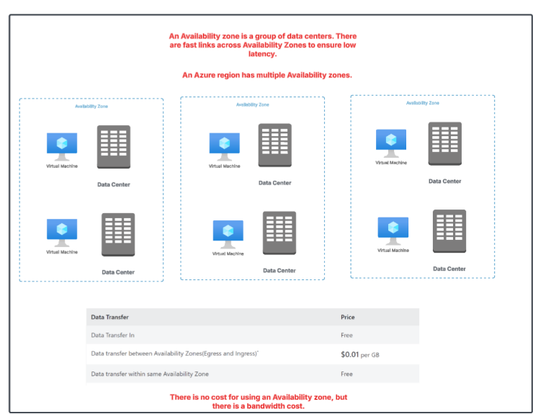

Azure India Region | Number of Availability Zones
Central India (Pune) | 3 zones Azure Speed+2Azure Speed+2
South India (Chennai) | 0 zones (no AZ support) Azure Speed
West India (Mumbai) | 0 zones (no AZ support) Dgtl Infra

GO TO THE VM AND IN AVALIBILITY OPTION USE AVALIBILITY ZONE:-
